H.T No
Regulations:
A22

Sreenidhi Institute of Science and Technology
(An Autonomous Institution)
Code No:9K406 Date: 08-August-2024 (FN)

B.Tech II-Year II- Semester External Examination, August-2024 (Regular)
STRUCTURAL ANALYSIS-I (CIVIL)

Time: 3 Hours Max.Marks:60

Note: a) No additional answer sheets will be provided.
b) All sub-parts of a question must be answered at one place only, otherwise it will not be valued.
c) Missing data can be assumed suitably.
Bloom's Cognitive Levels of Learning (BCLL)

Remember | L1 | Apply | L3 | Evaluate | L5
Understand | L2 | Analyze | L4 | Create | L6

Part - A Max.Marks: 6x2=12

Answer all QUESTIONS, EACH QUESTION CARRIES 2 MARKS.

 |  | BCLL | CO(s) | Marks
1 | Define types of Frames | L1 | CO1 | [2M]
2 | Define the types of Arches | L1 | CO2 | [2M]
3 | Define the static and kinematic indeterminacy of beam | L1 | CO3 | [2M]
4 | Write the effects of sinking supports | L1 | CO4 | [2M]
5 | Write the equation for slope deflection method | L1 | CO5 | [2M]
6 | Define ILD | L1 | CO6 | [2M]

Part – B Max.Marks: 6x8=48
ANSWER ALL QUESTIONS. EACH QUESTION CARRIES 8 MARKS.

 |  | BCLL | CO(s) | Marks
7. | Analyse the truss as shown in the figure below  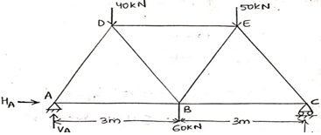 | L5 | CO1 | [8M]
 | OR
8 | Define frame and Explain in detail about different types of frames | L2 | CO1 | [8M]
9. | A Three hinged arch has a span of 30m and rise of 10m. the arch carries udl of 0.6KN/m on the left half of the span . It also carries two concentrated load of 1.6KN & 1KN at 5m &10m from right end .Determine Reactions at the supports | L3 | CO2 | [8M]
 | OR
10 | A symmentrical three hinged arch of span 20m and a rise of 4m carries a point load upto 4KN at 4m span from left the left support calculate Normal thrust, Radial Shear and maximum bending moment | L5 | CO2 | [8M]
11 | A propped cantilever beam of3 m long has 100mm wide and 150mm deep cross section . If the allowable bending stress and the deflection at the center is 4.5MPA and 2.5 respectively . Determine the safe udl load the beam can carry take E=120GPA | L4 | CO3 | [8M]
 | OR
12 | A cantilever beam of span 6m carries a point load of 18kN at 2m from fixed end. If the beam is propped at free end determine magnitude and prop reaction | L3 | CO3 | [8M]
13 | 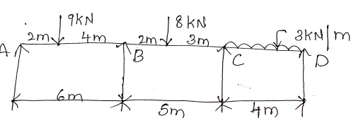  A continuous beam of span ABCD is simply supported at A ,B, C, D . Find the moments and draw the SFD &BMD Using Three moment method | L4 | CO4 | [8M]
 | OR
14 | 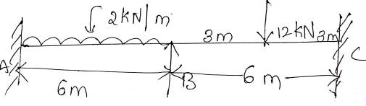  Draw the SFD & BMD For the given beam using Three moment method | L5 | CO4 | [8M]
15 | 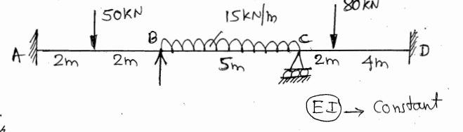  Draw the SFD & BMD For the given beam using slope deflection moment method | L5 | CO5 | [8M]
 | OR
16 | 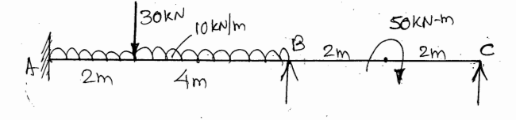  Draw the SFD & BMD For the given beam using slope deflection moment method | L4 | CO5 | [8M]
17 | A multiple points of 100KN, 120KN, 80KN, 150KN with a spacing of 2m crosses a girder of span 28m from left to right with 100KN load leading calculate  1)Reactions  2)Max SF at a section 12m from left  3)Max BM at a section 12m from left | L3 | CO6 | [8M]
 | OR
18 | Define ILD. And simplify the ILD for simply supported beam | L2 | CO6 | [8M]

-- 00 -- 00 –

